**Quick tip :**

To remove all the recreated images( these will have <none> tag as shown in below image), please run the below command

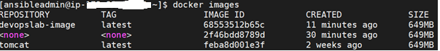

**docker image prune --filter="dangling=true"**

**OR**

**Edit your playbook and add the task as shown below.**

